CREATE TABLE BANK (
bankcode VARCHAR(3) PRIMARY KEY,
bankname VARCHAR(50) NOT NULL,
headoffice VARCHAR(50),
branches INT CHECK (branches > 0)
);
INSERT INTO BANK VALUES ('SBI', 'State Bank of India', 'Ernakulam', 22000);
INSERT INTO BANK VALUES ('HDF', 'HDFC Bank', 'Mumbai', 6000);
INSERT INTO BANK VALUES ('ICI', 'ICICI Bank', 'kottayam', 5000);
INSERT INTO BANK VALUES ('PNB', 'Punjab National Bank', 'Kottayam', 10000);
INSERT INTO BANK VALUES ('CAN', 'Canara Bank', 'Ernakulam', 9000);
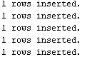
CREATE TABLE BRANCH (
branchid INT PRIMARY KEY,
branchname VARCHAR(50) DEFAULT 'New Delhi',
bankid VARCHAR(3),
FOREIGN KEY (bankid) REFERENCES BANK(bankcode)
);
INSERT INTO BRANCH VALUES (1, 'Kottayam', 'SBI');
INSERT INTO BRANCH VALUES (2, 'Ernakulam', 'HDF');
INSERT INTO BRANCH VALUES (3, 'Chennai', 'ICI');
INSERT INTO BRANCH VALUES (4, 'Delhi', 'PNB');
INSERT INTO BRANCH VALUES (5, 'Bangalore', 'CAN');
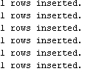
INSERT INTO BRANCH (branchid, bankid) VALUES (6, 'SBI');

CREATE VIEW bank_head_office AS
SELECT *
FROM BANK
WHERE headoffice = 'Mumbai';
CREATE VIEW bank_branch AS
SELECT B.*
FROM BANK B
JOIN BRANCH BR ON B.bankcode = BR.bankid
WHERE BR.branchname = 'Kottayam';
SELECT * FROM bank_branch;
SELECT * FROM BANK;
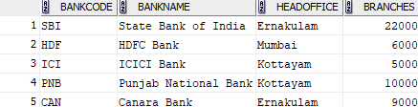
Ensure at least one row in BRANCH has branchname = 'Kottayam'
SELECT * FROM bank_branch;

SELECT * F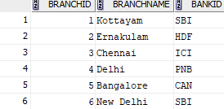ROM BRANCH;

CREATE VIEW banks_more_than_50 AS
SELECT *
FROM BANK
WHERE branches > 50;

CREATE VIEW bank_branch_details AS
SELECT B.bankname, BR.branchname
FROM BANK B
JOIN BRANCH BR ON B.bankcode = BR.bankid;

CREATE VIEW banks_outside_ernakulam AS
SELECT *
FROM BANK
WHERE headoffice <> 'Ernakulam';
The condition <> 'Ernakulam' means not equal to Ernakulam
SELECT * FROM banks_outside_ernakulam;

